Needs Assessment Element 1 Phase 1B: Financial Analysis

**UCLA Luskin Center for Innovation**

**Gregory Pierce and Julien Gattaciecca**

**(contact: jgattaciecca@luskin.ucla.edu; gspierce@ucla.edu)**

**April 1, 2020**

Report Overview

This document summarizes the data, analytical methods, initial results and potential next steps of the financial analysis portion of the California Water Board’s (the Board’s) initial statewide needs assessment (Element 1 Phase 1B). The original goals of this screening phase were to perform a Technical, Managerial, Financial (TMF) capacity analysis of all community water systems classified as “potentially at risk” during the first phase of the risk screening. The ultimate goal is to categorize those “potentially at risk” systems as either “healthy” or “at risk.”

However, due to the infeasibility of the original scope and changes in the Board’s goals for the risk screening, UCLA and the Board agreed to shift Element 1 Phase 1B from a focus on TMF for “potentially at risk” systems to a broader financial analysis of all small systems. This phase of research thus involved collecting, obtaining, and descriptively analyzing internal financial indicators for all community water systems with fewer than 3,300 connections in California for which data were available across the time period 2016-2018. This work provides a roadmap for replication and expansion of this analysis for the financial capacity component of future risk screening efforts.

Summary of Findings with Available Data

After conducting a thorough search of available data sources, we retrieved financial data for a total of 720 community water systems with fewer than 3,300 connections in California. This represents approximately 25% of all community water systems with fewer than 3,300 connections. These systems fall into four governance types: cities, investor owned utilities (IOUs), mutual water companies (MWCs), and special districts (SDs). In comparison, much better financial data coverage was available for larger systems.

The three financial metrics with reliable data available were:

* Operating ratio with depreciation (OrwD)
* Revenue per capita
* Days cash on hand

We also consider and discuss other metrics below.

#### High-Level Implications for Future Needs Assessment

* Our work resulted in manually obtaining and cleaning data on financial capacity indicators from 2016 to 2018 for 25% of all systems with <3300 connections
* The labor intensity of data collection and analysis involved in this process was high
* The data quality and appropriateness of certain metrics varies by system governance type (City, IOU, MWC, SD)
* Outliers for each metric may skew the reported sample characteristics, suggesting the medians may be more appropriate for comparison purposes
* Investor Owned Utilities had the highest mean and median operating ratio among system types, and also collected substantially more revenue per capita
* Special districts have the lowest mean and median operating ratio, and near the lowest revenue per capita, even when accounting for non-operating revenues

*Table 1: Financial metrics (medians) by ownership type*

|  |  |  |  |  |
| --- | --- | --- | --- | --- |
| ***Ownership*** | ***ORwD*** | ***Revenue/Capita*** | ***Days Cash on Hand*** | ***Number of Systems*** |
| Cities | 1.09 | 252 | 112 | 79 |
| IOUs | 1.22 | 894 | 131 | 74 |
| MWC | 1.09 | 405 | 309 | 262 |
| SD | 0.92 | 268 | *NA* | 305 |

* Water systems categorized as “in violation” in the initial risk screening generally have poorer financial performance than water systems categorized as “healthy”

*Table 2: Financial metrics (medians) by initial risk screening category*

|  |  |  |  |  |
| --- | --- | --- | --- | --- |
| ***Ownership*** | ***ORwD*** | ***Revenue/Capita*** | ***Days Cash on Hand*** | ***Number of Systems*** |
| In Violation | 0.99 | 276 | 196 | 73 |
| At Risk | 1.01 | 330 | 234 | 238 |
| Potentially at Risk | 1.04 | 314 | 273 | 215 |
| Healthy | 1.08 | 368 | 204 | 193 |

* There is no initial evidence that smaller systems within the sample have poorer financial performance than larger systems. This may, however, be due to self-selection issues and outside of sample data suggests larger systems have better available metrics

*Table 3: Financial metrics (medians) by size category*

|  |  |  |  |  |
| --- | --- | --- | --- | --- |
| ***Size*** | ***ORwD*** | ***Revenue/Capita*** | ***Days Cash on Hand*** | ***Number of Systems*** |
| <500 connections | 1.05 | 319 | 238 | 461 (64%) |
| >500 connections | 1.05 | 345 | 225 | 258 (36%) |

* Future financial capacity data collection could follow this data scraping model and proposed next steps, but would always remain limited in scope due to the labor associated with manual data collection and lack of data availability for some systems
* Additional regulation will be required to make financial analysis feasible across a significantly larger sample of small systems

Original Contract Scope: Financial Capacity Method

The original financial capacity analysis focused on estimating the adjusted operating ratio as shown below:

Adjusted Operating Ratio =

*\*With reserves including:*

* *Depreciation reserves for capital improvement*
* *Emergency reserves*
* *Operational reserves (or 1 month of operational expenses)*
* *Reserve for debt services*
* *Potential climate change resiliency reserve (or 2% of annual budget)*

The data collection for this calculation would be based on phone conversations with small systems but presents both benefits and challenges. One benefit of this ratio is that it estimates all assets and reserves necessary to operate water systems at all times. This method, however, presents substantial challenges around data collection and data quality for the 744 water systems categorized as “potentially at risk” in the contract scope risk methodology; this number includes 76% of water systems with less than 500 service connections. Conversations with water agency associations (ACWA, CMUA, CWA) indicated that it was unlikely that small systems, particularly those with fewer than 500 connections, would be able to easily provide this information via telephone. Finally, this formula combines all financial analysis into one metric, whereas several ratios may be more appropriate to represent on the on the statement of revenues and the balance sheet for each system.

Given these shortcomings, we decided to focus on publicly available data for small systems for this phase of the risk screening. Community water systems are not universally required to report financial capacity data to the Board or to any other state entity. While small systems do conduct TMF evaluations in the context of certain funding decisions by the Division of Financial Assistance, no database exists of that information.

The University of North Carolina Environmental Finance Center (UNC EFC) previously worked with other states to enhance understanding of system level financial capacity but the institutional diversity of small systems in California presents a challenge for similar data collection. In California, certain types of systems report financial data to state or federal authorities based on the respective requirements of these authorities. Very few small systems in California, however, are municipal entities as in other states, for which more data tends to be reported. Over a one-year period from Fall 2018 to 2019, UCLA researchers manually identified the potential data sources for the four governance types relevant to small (and larger) systems in California (investor-owned utilities, mutual water companies, cities and special districts).

This broader approach based in publicly available data provides several benefits as compared to the method planned in the original scope. First, it presents a broader vision of the financial capacity of small water systems across ownership types, sizes, and risk categories. In some cases, publicly available data also offer the opportunity to expand the financial analysis beyond operation revenues and expenses, to provide the Board with a broader understanding of the financial health of water systems in California, and potential for future expansion.

Revised Scope: Financial Capacity Metrics Considered

Relatively sparse published literature exists on the relationship between water system financial metrics and Human Right to Water outcomes, but financial capacity is a prerequisite to system investments that ensure high-quality, reliable water delivery.[1] We base our initial metric selection on data availability and existing industry and academic literature.[2] [3]As illustrated in the UNC EFC’s dashboard work in multiple states,[4] we propose the use of several financial ratios, thus allowing for an assessment of financial capacity beyond operational revenues and expenses.

For some ratios, the accuracy may vary by governance type and data availability. Not all indicators are available for all water systems included in this study. Furthermore, these metrics only serve as indicators rather than actual measurements of water system financial health. For example, the asset depreciation ratio heavily relies on the accuracy of the depreciation schedule and historic pricing of assets. Nevertheless, we believe that overall, these ratios provide a more comprehensive assessment of a system’s financial capacity than a single ratio.

The list of ratios below covers multiple aspects of the financial health of a company or enterprise fund, and were selected based on academic literature focused on water system financial capacity analysis: [5][6][7]

1. Operating ratio (incl. Dep.) =

The operating ratio including depreciation indicates whether operating revenues are sufficient to cover both operations and the necessary reserves that will be used for future capital investments (in the form of depreciation). We expect a system with a ratio higher than 1 to collect enough operating revenues (mainly through water charges only) to cover both its costs as well as future investments necessary to maintain normal operations. However, some experts prefer an operating ratio including depreciation above 1.2, and others recommend a ratio as high as 1.3 depending on necessary reserves.[8] We do not recommend a numerical standard at this time. We focus on the ratio including depreciation rather than the simple operating ratio in order to account for asset depreciation, which is essential to sustainably maintaining reliable infrastructure.[9]

2. Revenue Collection per Capita =

This ratio of average revenue per individual is a rough indication of a system’s fiscal capacity.[10]

3. Days of Cash on Hand =

This indicator represents the number of days a system can operate without receiving any more revenues from customers. In the case of emergencies (such as the current COVID-19 crisis), this indicator helps identify the system’s reserves with respect to the expenses required to deliver water to customers while keeping a system solvent. It is also an important ratio to use with the asset depreciation ratio.

Industry groups recommend systems maintain operating reserves of one to three months.[11] More specifically, in 2015, Fitch Ratings reported that the median days of cash on hand for A-rated water and sewer systems was 366 days, and 481 days for AAA-rated systems.[12] Standard & Poors targets are lower than Fitch: “S&P suggest that 30 to 60 days of cash is adequate, 60 to 120 days is good, and greater than 120 is strong.[13]

4. Asset Depreciation =

This ratio indicates the infrastructure condition of the water system by comparing the amount of assets depreciated to the total amount of assets that can be depreciated. In other words, the asset depreciation ratio indicates the remaining life expectancy of the utility plant. The higher this number is, the older the utility plant.

5. Other financial ratios to be considered:

The literature review suggests additional financial ratios related to debt, net assets, and current assets and liabilities could be useful for gauging financial health of water systems. Allocating more time and resources to the risk screening phase could allow UCLA or Board researchers to further investigate those ratios whenever possible:[14]

Debt Service Coverage Ratio =

Current Ratio =

Debt to Equity Ratio =

*Table 4: Available financial metrics by ownership type*

|  |  |  |  |  |
| --- | --- | --- | --- | --- |
|  | **MWCs** | **IOUs** | **Cities** | **Special Districts** |
| Operating Ratio Inc. Depreciation | √ | √ | √ | √ |
| Revenue per Capita | √ | √ | √ | √ |
| Days of Cash on Hand | √ | √ | √ | To be manually extracted |
| Asset Depreciation | √ (50%) | √ | Only provided by some systems | |
| Current Ratio | To be manually extracted | √ | To be explored further | |
| Debt to Equity Ratio | √ |
| Debt Service Coverage Ratio | √ |

Section 1: Mutual Water Companies

The Board’s list of community water systems with less than 3,300 service connections includes 582 mutual water companies (MWCs). Financial data was available for only 302 of these systems between 2004 and 2018. Only 262 of those provided financial information for at least one year between 2016 and 2018. This analysis focuses on those 262 MWCs in order to maintain the same time period of analysis across ownership types.

#### Sources

Given their unique governance type, mutual water companies are exempt from income taxes and required to file an Internal Revenue Service Form 990 with the federal government.[15] When filled out, this form provides a number of important financial data points: total revenue, total expenses, depreciation, assets, liabilities, and cash. In some cases, this form also provides a precise breakdown of revenues and expenses, as well as assets and liabilities. For example, some financial metrics important for our analysis such as accumulated depreciation and total depreciable assets were found for 98 MWCs, but not others. We note that these financial statements are not audited.

This financial information was obtained from a thorough online search. Most of the I-990 forms were found via the two publicly-accessible websites below:

[**https://990finder.foundationcenter.org/**](https://990finder.foundationcenter.org/)

[**https://www.open990.org/**](https://www.open990.org/)

These forms come in PDF format, as illustrated in the Appendix 1, which required manual extraction of the financial metrics necessary for our analysis, for every MWC each year.

#### Methodology

Because the MWC I-990 forms do not explicitly report operating revenues and expenses, we used total revenues and total expenses instead.[16] These forms do not distinguish operating from non-operating revenues and expenses. While the majority of systems provide a detailed breakdown of financial expenses, very few provide a breakdown of their financial revenues.

If the Water Board decides to move forward and estimate operating ratios for MWCs, it should consider the following two suggestions: i) identify which metrics should be included in operating expenses and revenues, and those included in non-operating expenses and revenues; ii) allocate sufficient resources to extract all necessary metrics from the PDFs for this analysis. Based on the time needed to extract only six financial metrics for 262 MWCs between 2012 and 2018, obtaining the data necessary to calculate operating revenues and expenses will require important resources and time.

Given resource constraints and data paucity, we decided to only collect the following financial metrics for 262 MWCs, between 2016 and 2018:

* Total revenues
* Total expenses
* Depreciation
* Cash (only 267 MWCs)
* Total assets and liabilities (only 200 MWCs)
* Accumulated depreciation and total depreciable assets (only 100 MWCs)

None of the MWC systems in this study reported debt interest expenses. Consequently, most of the financial ratios related to debt are not included in this analysis. Thus, we focus on the following ratios:

* Total Revenue / Total Expenses including Depreciation
* Revenue per capita
* Days of cash on hand
* Asset depreciation

#### Results

Figure 1 below presents the distribution of 262 MWCs by their self-reported revenue/expenses ratio, including depreciation. For simplicity, this ratio is renamed “operating ratio” in this document, and is compared to the operating ratios of other system ownership types. This ratio averages up to three years (2016-2018) of data on revenues, expenses, and depreciation (for a minority of systems only one or two years of financial data were available). Out of 262 water systems in this sample, 70% of them have an operating ratio above one, 6% have an operating ratio below 0.75. The median and average over all 262 systems is 1.09 and 1.23, respectively.

*Figure 1: Operating Ratio of Mutual Water Companies*

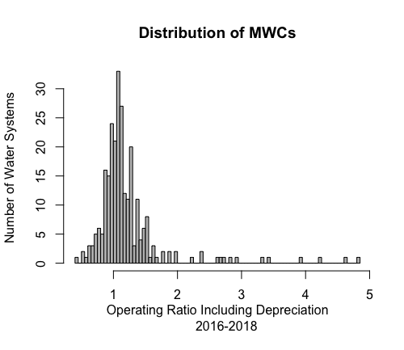

Figure 2 below presents the distribution of water systems based on their total revenue per capita. The average across all MWCs is $859 per capita, and the median is $405.[17]

*Figure 2: Revenue per Capita of Mutual Water Companies*

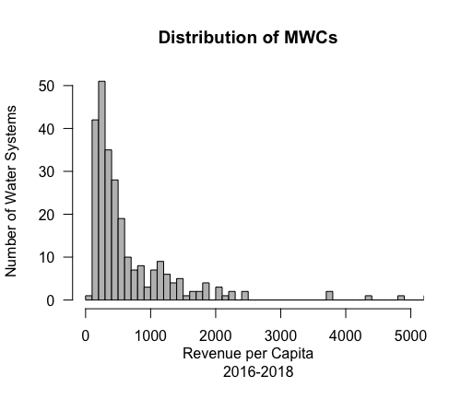

Figure 3 presents the distribution of MWCs by days of cash on hand.[18] The mean is 675 days and the median is 306 days. These levels of liquidity far exceed the operating reserves standard of one to three months recommended by industry groups.[19] More specifically, these MWCs have liquidity levels similar to A-rated systems: according to Fitch Ratings, the median days of cash on hand for A-rated water and sewer systems was 366 days in 2015, and 481 days for AAA-rated systems.[20]

*Figure 3: Days of Cash on Hand of Mutual Water Companies*

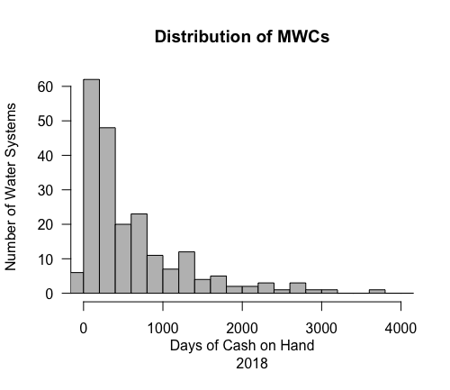

Figure 4 below shows the distribution of MWCs based on their asset depreciation. We only found the necessary data for 100 MWCs. The asset depreciation ratio is estimated by dividing the accumulated asset depreciated by the total amount of assets depreciable. A score closer to 1 shows the system has older infrastructure in need of replacement. The figure shows that most systems score between 0.4 and 1, with the median and the mean around 0.56. This ratio is probably best put in perspective alongside the amount of cash on hand for each system. As a system’s asset depreciation increases, so does the likelihood of requiring future expansive capital investments. In this particular context, MWCs have older infrastructure but also present much higher liquidities than the other ownership types.

*Figure 4: Asset Depreciation of Mutual Water Companies*

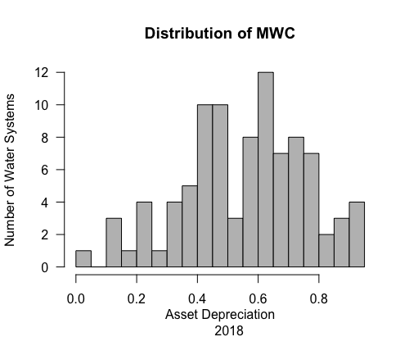

Section 2: Investor Owned Utilities

#### Sources

We retrieved the financial metrics for 74 investor owned utilities (IOUs) with less than 3,300 service connections[21] from annual reports for 2016-2018 filed on the California Public Utilities Commission (CPUC) website below:

ftp://[ftp.cpuc.ca.gov/waterannualreports/Water%20Division/Annual%20Reports/](http://ftp.cpuc.ca.gov/waterannualreports/Water%20Division/Annual%20Reports/).

These forms come in PDF format, as illustrated in the Appendix 1, which manual extraction of the financial metrics for every utility each year.

Regulation by the CPUC requires all IOUs to report their financial performance in identical fashion on an annual basis. This results in an important wealth of information and financial reports that are consistent across systems. For this reason, the financial analysis of the IOUs is the most consistent and the rigorous analysis in this report.

#### Methodology

We manually extracted the following financial metrics for as many small IOUs as possible, for 2016, 2017, and 2018:

* Operating revenues
* Operating expenses
* Depreciation

We then extracted the following metrics only for 2018:

* Cash
* Total assets and liabilities
* Total current assets and current liabilities
* Accumulated depreciation and total depreciable assets
* Long term debt and interest expenses

IOUs offer enough financial information and homogeneous reporting methods to allow for the estimation of all financial ratios discussed above. Due to time and resources constraints, we only focused on the same ratios that are estimated for other system ownership types.

* Operating ratio including depreciation
* Revenue per capita
* Days of cash on hand
* Asset depreciation

#### Results

Figure 5 below illustrates the distribution of IOUs based on their operating ratio, including depreciation. The mean and median are 1.23 and 1.21 respectively. 78% of all IOU systems sampled have an OR including depreciation above or equal to 1, and only two systems (3% of sample) have an OR below 0.75. Unsurprisingly, given their rate of return authorities from the CPUC, these metrics for IOUs generally look healthier than those of cities, special districts, and MWCs.

*Figure 5: Operating Ratio of Operating Ratios of Investor Owned Utilities*

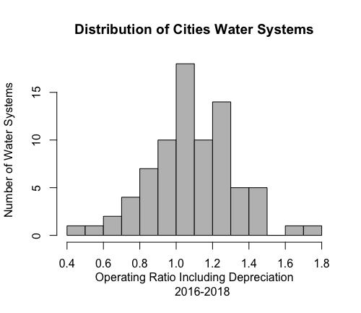

Figure 6 below presents the distribution of IOUs based on their revenue per capita.[22] The mean and median are $1,362 and $894 per capita, respectively. This is much higher than the revenues per capita estimated for cities, special districts, and MWCs.

*Figure 6: Revenue per Capita for Investor Owned Utilities*

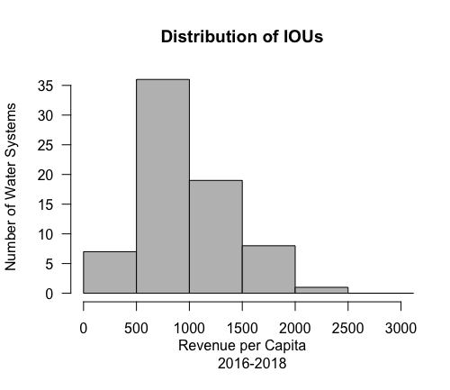

Figure 7 illustrates the distribution of IOUs by the number of days of cash on hand. The mean is 198 and the median 130; 27% of IOUs have less than 30 days of cash on hand. This is half the number of days MWCs have, but above the numbers estimated for city-run water systems. These differences may be explained by several factors: differences in financial regulation, investor decisions (redistribution of dividends), or capital investment approaches that favor debt (to leverage equity) over cash on hand. Further exploration of this topic and discussion with industry experts can assess how these numbers relate to other water system types.

*Figure 7: Days of Cash on Hand for Investor Owned Utilities*

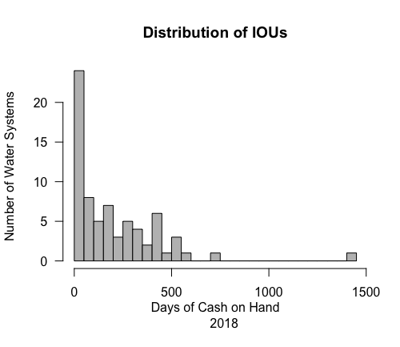

Figure 8 presents the distribution of IOUs by asset depreciation ratio. The mean of 0.45 and median of 0.43 indicates IOUs have newer infrastructure than MWCs. This is unsurprising given that IOUs have the incentive and authorization to receive a rate of return on their capital investments via the rate-making process. Higher levels of regular capital investments might explain lower asset depreciation ratios, and lower amounts of cash on hand. This could be assessed by looking at annual investments over a longer time period of data.

*Figure 8: Asset Depreciation of Investor Owned Utilities*

# 

Section 3: Cities and Special Districts

#### Sources

We identified 305 small water systems run by special districts and 79 small water systems run by cities (with less than 3,300 service connections). Financial capacity data for these two different governance types comes from the same source so they are combined in this section.

The California State Controller’s Office aggregates financial information for these system types, which is made available on the website below. Unlike with MWCs and IOUs, this data is provided in Excel spreadsheet rather than PDF format, making it somewhat easier to collect. To make this data usable, we had to manually match each enterprise fund to the correct water systems and California ID numbers as provided in SDWIS.

<https://bythenumbers.sco.ca.gov>

Generally speaking, cities and special districts provide one dataset per year that compiles all financial information for each local government, including both city enterprise funds and general funds. These spreadsheets provide the statement of revenues and expenses for Water Enterprise Funds, and balance sheets aggregated at the local government level. Examples of these can be found in the Appendix 1.

As a major limitation to these datasets, the State Controller’s Office only provides the balance sheets aggregated at the City or County level (general fund and enterprise funds together), despite providing detailed revenue statements for enterprise funds separately. Consequently, most of the ratios that require financial metrics included in the balance sheet (assets and liabilities) cannot be estimated from this data source. Estimating all financial ratios for every enterprise fund would require retrieving metrics from PDF versions of cities’ and counties’ Comprehensive Annual Financial Reports (CAFR) such as, but not limited to, cash, accumulated depreciation, total depreciable assets, principal, total assets, etc. We collected cash data from CAFRs to estimate days of cash on hand for city-run systems, but additional manual data collection was not possible within our timeframe.[23]

#### Methodology

Based on the publicly available data, we collected the metrics below for the three most recent years: 2016, 2017, and 2018:

Total operating revenue

Total operating expenses

Depreciation

Transfers in and transfers out of the enterprise fund

Due to some discrepancies between the 2016, 2017, and 2018 datasets, we needed to manually reconcile the data. As with other governance types, we averaged revenues, expenses and depreciation over three years in order to reduce the impact of potentially abnormal revenue or expenses during a specific year.

#### City-Run Systems Results

Figure 9 below presents the distribution of all city-run water systems with less than 3,300 service connections by their estimated operating ratio including depreciation. The operating ratio was estimated by averaging three years (2016-2018) of revenues, expenses, and depreciation. Out of 79 city-run water systems in this sample, 68% have an operating ratio greater than one, whereas 6% have an operating ratio below 0.75. The median and average for the entire sample size are both 1.09. When estimating this ratio over all city-run water systems, including those larger than 3,300 service connections, 79% have an operating ratio greater than one. This suggests that larger systems, even within the same governance type, have better financial performance, most likely due to broader financial capacities and synergies.

*Figure 9: Operating Ratios Including Depreciation of City-Run Water Systems*



Figure 10 presents the distribution of water systems based on their total revenue per capita. The average operating revenues per capita across city-run water systems with less than 3,300 service connections is $276, and the median is $251. These figures are substantially below both the average and median for MWCs and IOUs.

*Figure 10: Revenue per Capita of City-Run Water Systems*

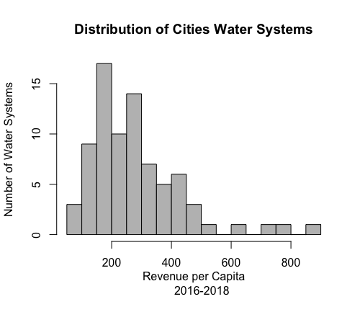

Figure 11 shows the distribution of transfers in and out of the enterprise funds (via the general fund) of city-run water systems. The ability (or liability) of external transfers in and out of city-run water systems is unique to this governance type. When that number is positive, the water system received more money from the general fund over the past three years than was sent to the general fund. On average, cities transfer $81,000 to their general funds every year from their enterprise funds. The median transfer amount is zero. While much controversy surrounds transfers from enterprise funds to general funds (and vice versa), some level of transfer may be justified by general service functions cities perform for their enterprises.

*Figure 11: Net Transfers into Enterprise Funds of City-Run Systems*

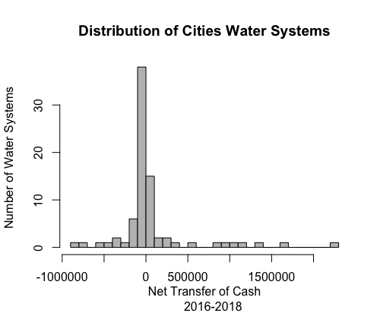

We looked for CAFRs for the 79 city-run systems to retrieve the amount of cash available in their balance sheets. We found that the smallest cities do not have their reports online, but in most cases they can be obtained in person at city halls. For the other 67 systems, 5 had no cash available; the remainder are illustrated in Figure 12 below. The mean and median days of cash on hand for cities are 160 and 111, respectively, and 20% of those systems have less than or equal to 30 days of cash on hand.

*Figure 11: Days of Cash on Hand for City-Run Systems*

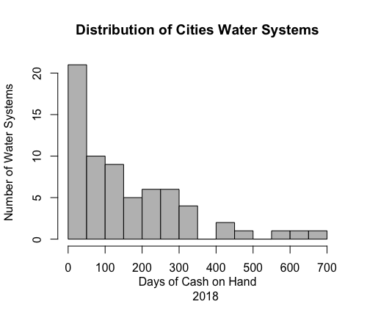

#### Special District Systems Results

The State Controller’s Office also provides statements of revenue data for more than 900 special district water enterprise funds. We identified and matched 305 of those enterprise funds with the correct drinking water systems[24] (<3,300 SC) provided by the Board and estimated their operating ratio and revenue per capita. As illustrated by Figure 13, Special District-run water systems have lower operating ratios than cities, IOUs, and MWCs. On average, these 305 small special district systems have an operating ratio including depreciation of 0.91, whereas city-run water systems with less than 3,300 service connections have an average of 1.09. In contrast to other system types, the majority of Special Districts have an OR below 1; only 35% of special districts have an operating ratio above 1.

*Figure 13: Operating Ratios including Depreciation for Special Districts*

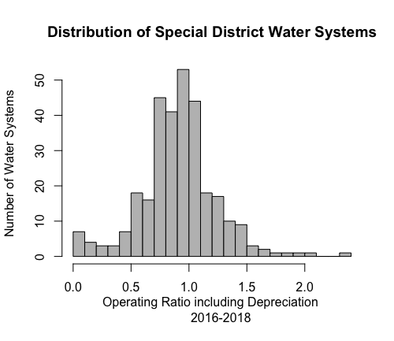

These proportions do not change even if we include all special district water systems above 3,300 service connections. This increases the sample size by a factor of three and increases the potential synergies but still only 39% of all special districts have an operating ratio greater than one. Their comparatively poor financial performance could be explained by the fact that most special districts receive substantial revenues from non-operating sources like county taxes, which we might be able to account for in the future. Consequently, it is likely that these systems purposely keep their water rates low to offset part of their operational losses with non-operating revenues.

To assess this assumption, we looked at the ratio of total revenue divided by total expenses, similar to the methodology used for MWCs. With this ratio, approximately 65% of special districts are above 1 (see Figure 14), which is still lower than the ratios found for cities, IOUs, and MWCs. Further research and interviews should be conducted to assess the accuracy of these ratios as indicators of good or poor financial management for these types of systems.

*Figure 14: Total Revenues to Expenses Ratio of Special Districts*

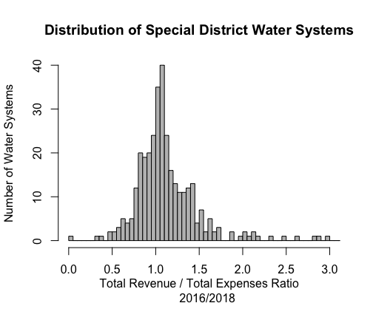

Figure 15 presents the distribution of small special districts based on their revenue per capita. The average revenue per capita for the 305 special districts is $370, and the median is $268. This is lower than IOUs and MWCs, but slightly higher than the city-run systems.

*Figure 15: Revenue per Capita of Special Districts*

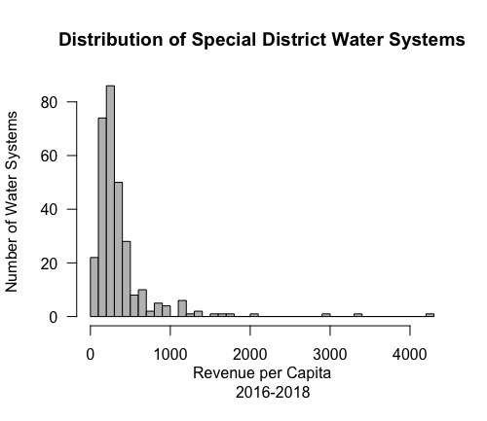

We looked at transfers the same way we did for cities, and found that on average, special districts transfer $22,600 to their county’s general fund, although the median transfer amount is also zero.

Next Steps

In addition to the suggestions above, we identify several potential next steps for analysis, depending on the Board’s interests. We focus on the deepening of analysis and extension of the sample for risk screening purposes. This document presents descriptive trends in financial metrics. We refrained from further analysis and judgment of risk based on these metrics both due to time constraints and the need for feedback from the Board and stakeholders. Potential further analyses include:

* Comparison of these metrics to larger systems using readily-available data for larger cities, special districts and MWCs (pending extraction)
* Establishment of conservative, bright line thresholds for metrics already-established (e.g., three year ORwD score of less than 0.75 as risk factor)
* Correlational and causal relationships between financial metrics, system size, governance type and elements of risk or outcomes of interest (violations, rates) identified elsewhere in the Needs Assessment process

In a 3-month time frame, we are only able to collect and perform descriptive analysis on a quarter of smaller systems. For the purpose of risk screening, we expect systems that do not report any publicly-available financial data to likely be in worse financial condition. The inclusion of more of these systems seems necessary in order to include financial capacity alongside other risk metrics in future screening. There are three opportunities for expansion of data collection for certain types of small systems:

* Expanded MWC data collection (300+ systems) with better data sourcing from the IRS
* Survey of mobile home park water system finances (350+) through the California Housing Community Development Department, although an initial attempt to do this was not successful
* Scraping of data for up to 450+ other systems that appear to be residential associations of some sort, as outlined in Appendix 2

In regards to the third and final opportunity, the availability and quality of water system-specific operation finances, as opposed to housing complex operation finances, for small MHPs and HOAs or other residential operations is questionable; many of these systems lump fees for water service in with rent. Even in a best case and unlikely scenario where sufficiently high-quality financial data for all of these systems were included via these approaches, this additional data would cover about two-thirds of all systems with fewer than 3,300 connections (n=1800).

Accordingly, we suggest the need for additional reporting requirements or regulation at the state-level to make financial analysis feasible across a significantly larger sample of small systems, in order to meaningfully expand the risk screening. An alternative or complementary idea is a simple, standalone financial survey sent exclusively to small systems. This idea appears to be supported by major water system associations (ACWA, CUWA, CWA).

Appendix 1: Examples of Raw Data Sources

##### Examples of financial reports that can be found for Mutual Water Companies:

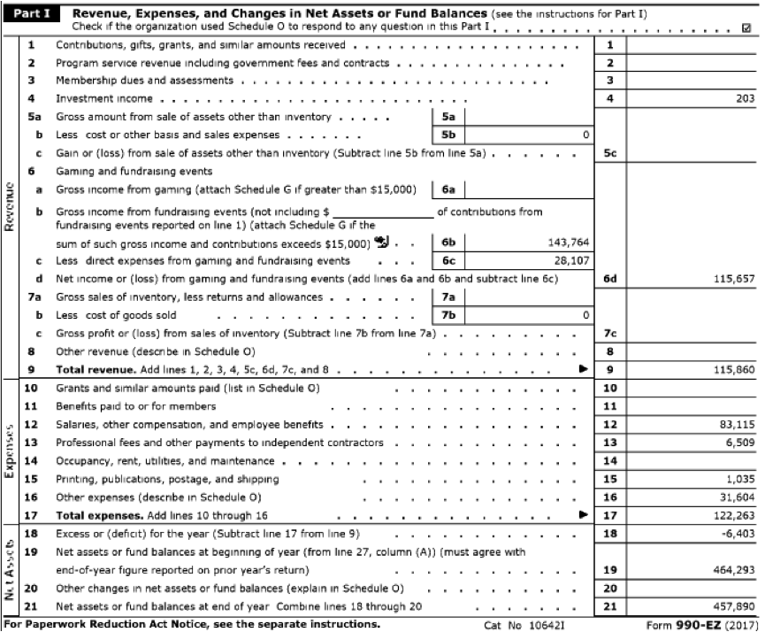

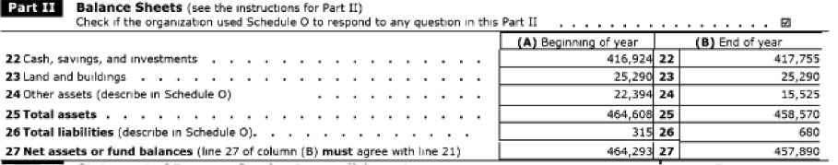

##### Examples of financial reports that can be found for Investor Owned Utilities:

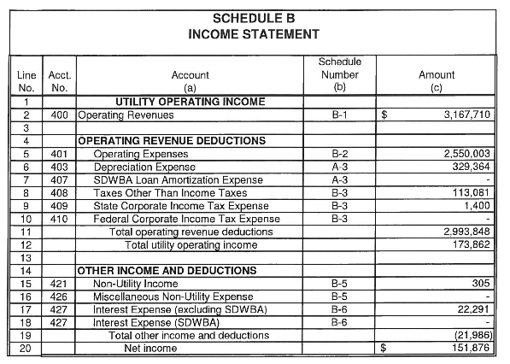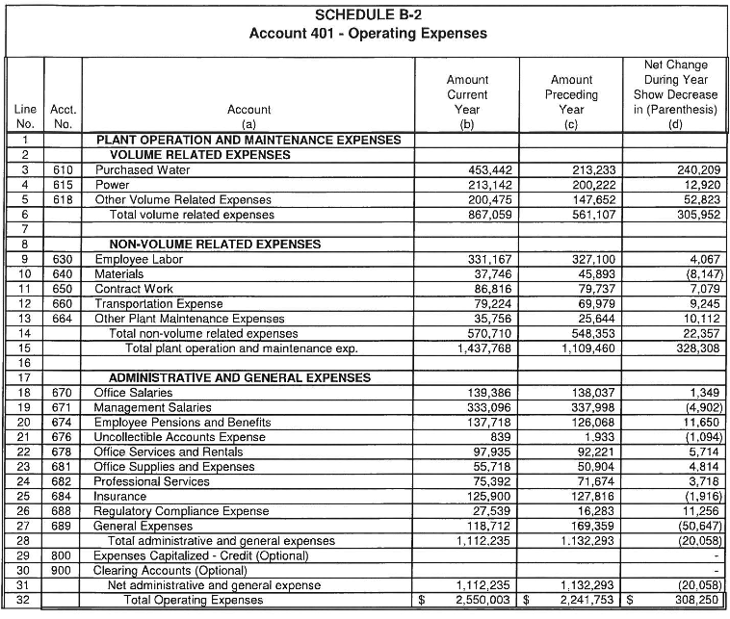

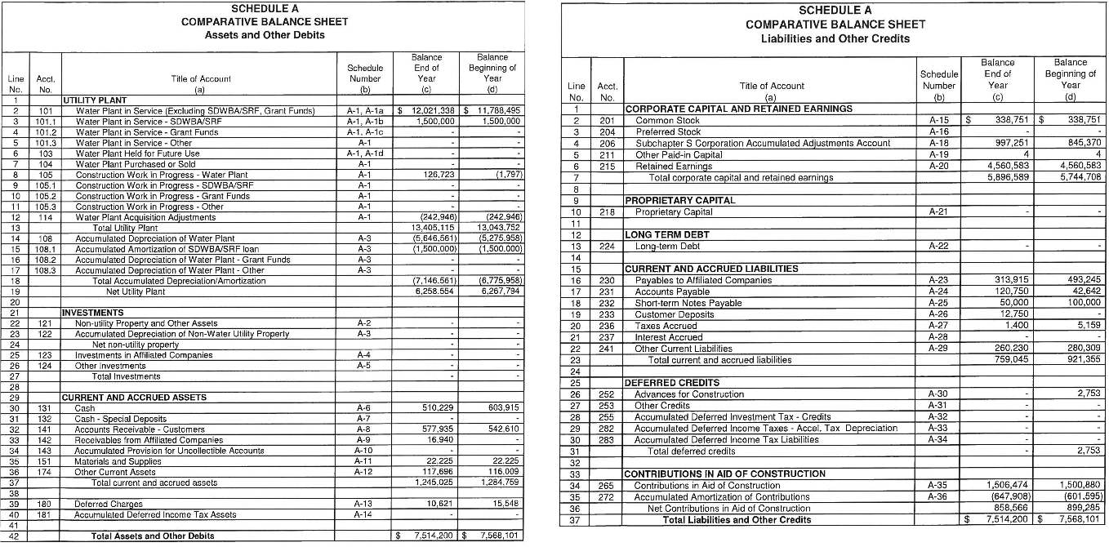



##### Example of data that can be found at the State Controller’s Office website for cities or special districts:

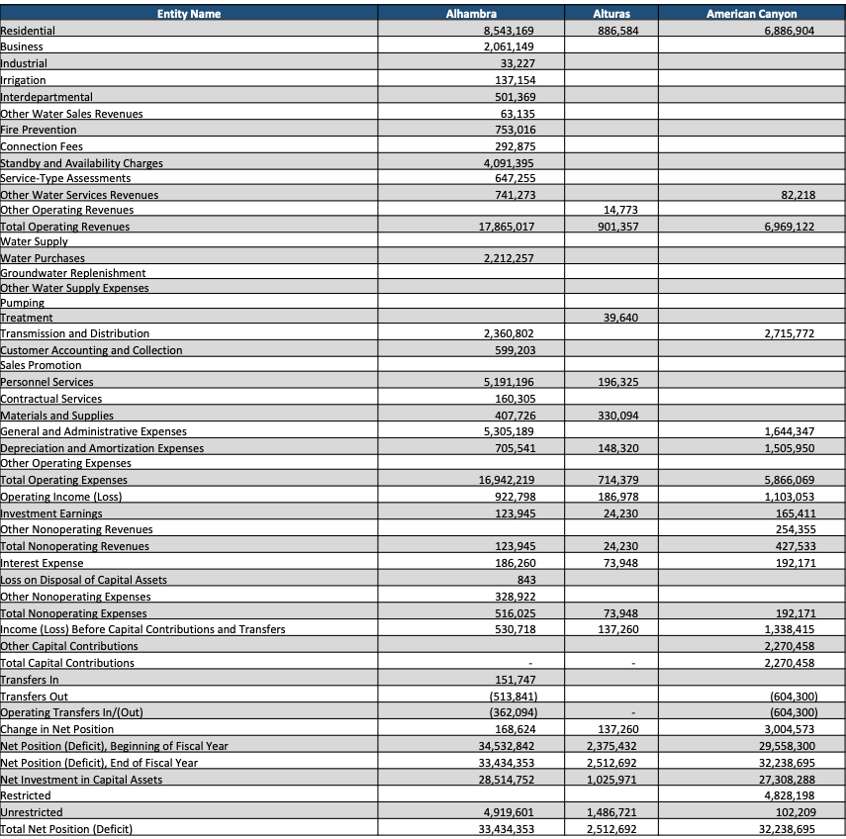

##### Example of Comprehensive Annual Financial Reports (CAFR) that can be found on most city websites:

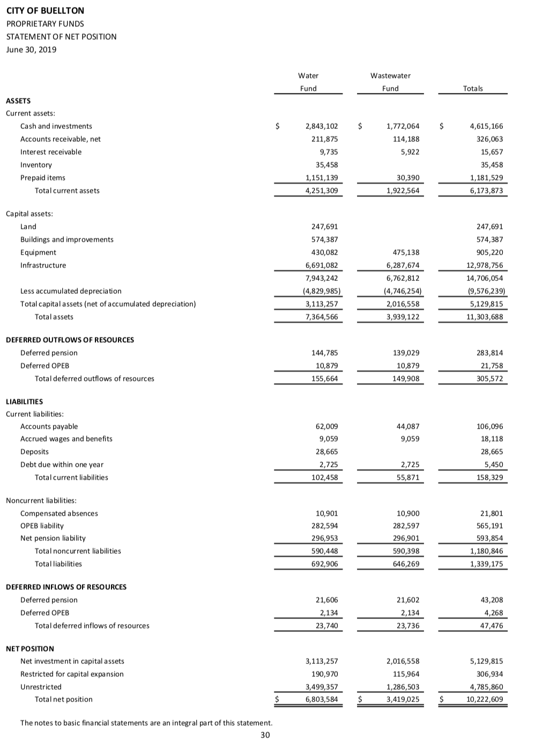

Appendix 2. Detailed recommendations for potential next steps in data collection

In order to identify additional sources of financial information for other small water system types, we interviewed Professor Camille Pannu, director of the Aoki Water Justice Clinic at UC Davis, and visiting assistant clinical professor of Law at UC Irvine, as an expert in small water system law and governance.

All small water systems which are home-owners associations (HOA) have to file financial reporting with the Internal Revenue Services (IRS), despite being classified as non-profits. Most of them are incorporated as 501(c)7 and are consequently required to submit a 990 form. Dr. Pannu recommended searching for those forms on the IRS website: <https://apps.irs.gov/app/eos/>.

After a few attempts, it appeared that the water system names rarely match the HOA names, which makes the search tool difficult to use. Consequently, the first step would be to download the list of all tax exempt organizations that filed a 990 form from this webpage: <https://www.irs.gov/charities-non-profits/tax-exempt-organization-search-bulk-data-downloads>. Then, the resource intensive process of reconciling each water system name with the correct organization listed could lead to better results with the IRS research tool. An important caveat is that not all organizations are in active standing, and only those that have annual income greater than $50,000 are required to file.

Moreover, the Davis-Stirling Act requires condo associations to file some financial data with the Bureau of Real Estate, and to submit their public budget for inspection to their members, including fiscal year financial reports with actual versus budgeted information. This law applies to any development created by a single developer that was subdivided after 1976, which includes some mobile home parks (MHPs) that are not technically considered MHPs but for which some community members still live in mobile homes.

Even in the best case scenario where raw data is available through these avenues, manually extracting data for hundreds of systems from PDFs is time consuming and error prone. If this financial analysis proved necessary, we advise the Board to explore ways of streamlining and automating this process through electronic reporting or partnerships with other state agencies.

1. Teernstra, B. (1993). How Will Small Water Systems Finance SDWA Compliance?. *Journal‐American Water Works Association*, *85*(6), 43-46.
2. The Environment Finance Center at Boise University - (2001). The Ratio 8 system: a financial assessment tool that analyzes water systems’ financial condition using eight ratio formulas. Many subsequent studies use this formula, which was inspired by the combination of multiple academic journal publications prior to 2000.
3. American Water Works Association (2014). *M29 Manual of Water Supply Practices: Water Utility Capital Financing.* Page 56 “Some key financial ratios used by credit rating agencies”
4. See [efc.sog.unc.edu](https://efc.sog.unc.edu/) for multiple examples.
5. DW Wirick et al. (1997). *Evaluating Water Utility Financial capacity with ratio analysis and discounted cash flows*
6. B. Brown et al.(2005) *Measuring Financial Capacity and the Effects of Regulatory Changes on Small Water Systems in Nova Scotia* , Canadian Water Resources Journal, 30:3, 197-210, DOI: 10.4296/cwrj3003197
7. Blanchard, C. S., & Eberle, W. D. (2013). Technical, managerial, and financial capacity among small water systems. *Journal‐American Water Works Association*, *105*(5), E229-E235.
8. University North Carolina - Environmental Finance Center (2015). [Key Financial Indicators for Water and Wastewater Systems: Operating Ratio](http://efc.web.unc.edu/2015/02/27/operating-ratio/)
9. In the case of mutual water companies, detailed below, we use total revenues and expenses as a necessary substitute for operating figures.
10. See Scott, T. A., Moldogaziev, T., & Greer, R. A. (2018). Drink what you can pay for: Financing infrastructure in a fragmented water system. *Urban Studies*, *55*(13), 2821-2837.
11. According to the literature review conducted by the American Water Work Association (AWWA) the Water Environment Federation recommends one to three months; the International City/County Management Association recommends one to two months of expenses; and, the Government Finance Officers Association recommends no less than 45 days.
12. The environmental finance blog of UNC EFC (2015). “[Key Financial Indicators for Water and Wastewater Systems: Days of Cash on Hand](http://efc.web.unc.edu/2015/06/24/days-cash-on-hand/)
13. American Water Works Association (2014). *M29 Manual of Water Supply Practices: Water Utility Capital Financing.* Page 58
14. We foresee some limitations to this exercise. None of the MWCs included in this financial analysis reported any type of debt or interest payments between 2016 and 2018. None of the MWCs explicitly reported their current assets or liabilities; this can be estimated for at least some of the systems, but requires manual extraction of several financial metrics and may be limited by the heterogeneity of MWCs’ financial reports. Cities and counties provide information regarding bonds issuance, yet reconciling this information with interest payment has proven more complex than originally anticipated. If the Board decides to estimate those additional ratios for cities and counties, we suggest interviewing some city and special districts’ financial departments to better understand their reporting practices. Finally, to retrieve current assets, net assets and current liabilities, one would need to find and manually extract that data from cities’ and counties’ comprehensive annual financial reports, which is time and resource intensive. IOUs, on the other hand, provide all necessary information to estimate those ratios. We already manually extracted them, and a third of the IOUs are or have been using debt in the past three years.
15. See <https://www.irs.gov/forms-pubs/about-form-990> more information regarding requirements for I-990 filing status.
16. To improve the existing comparison of financial ratios across system types, one needs to distinguish MWCs’ operating revenues and expenses from their non-operating revenues and expenses.
17. To improve readability, we limit the x axis to $5,000 of total revenue per capita maximum. The following four systems are not represented in this graphic: Solano Verde ($6,500), Valley Vista ($9,500), San Cayetano ($13,000), and Lloyd-Butler($27,000 ). None of those systems were excluded from the dataset or calculations.
18. We excluded one system from this graph: Lundy MWC, which has 21,000 days of cash on hand
19. According to the literature review conducted by the American Water Work Association (AWWA): the Water Environment Federation recommends one to three months; the International City/County Management Association recommends one to two months of expenses; and, the Government Finance Officers Association recommends no less than 45 days.
20. The environmental finance blog of UNC EFC (2015). “[Key Financial Indicators for Water and Wastewater Systems: Days of Cash on Hand](http://efc.web.unc.edu/2015/06/24/days-cash-on-hand/)
21. System-level financial data are not typically available for small IOUs which are part of larger utilities with >3300 connections across all systems in the utility. In those cases, financial information is typically reported for the whole utility (ie Golden State Water Company) and not for the smaller community water system per se (ie, Golden State Water Company- Edna).
22. To improve readability, we limited the x axis to $3,000 of total revenue per capita maximum. The following two systems are not represented in this graphic, but are included in the dataset and the calculations: Canada Woods ($6,600), and Ramona Water Company ($24,000).
23. It may be possible to increase the number of financial ratios we currently have for cities and counties. This can be done by following the following two steps: i) manually retrieve cash, total assets and liabilities, current assets, net assets and current liabilities from comprehensive financial annual reports (CAFRs), which will be time and resource intensive for all systems. ii) use the cities and counties dataset for bonds issuance data, but reconciling this information with interest payment will be complex due to data limitations. We suggest interviewing city and county financial departments to better understand reporting practices before integrating debt information.

   
24. This is a complicated process as there are many other “water” special districts included in the raw data which are not public water systems, including water wholesalers and irrigation districts.